Daisy Nairuba

CTEC 298-101

Dr. Bemley

**SIX PLOTS ASSIGNEMT**

Upload a document which shows the six plots, with python code and descriptions, required for this class.

**Bar plot -**

Description: are used to compare and measure things from different groups over time. They are useful to track large changes overtime between compared data groups. They can be displayed vertically and horizontally with just an x-axis and y-axis with categorical variable

**Pie Chart/Plot –**

Description: Pie Chart plots are circular statistical plots used to represent one series of data. The area of the chart is total percentage of the given data while the area of slices(proportions) represents the percentage of the parts of the data.

**Histogram –**

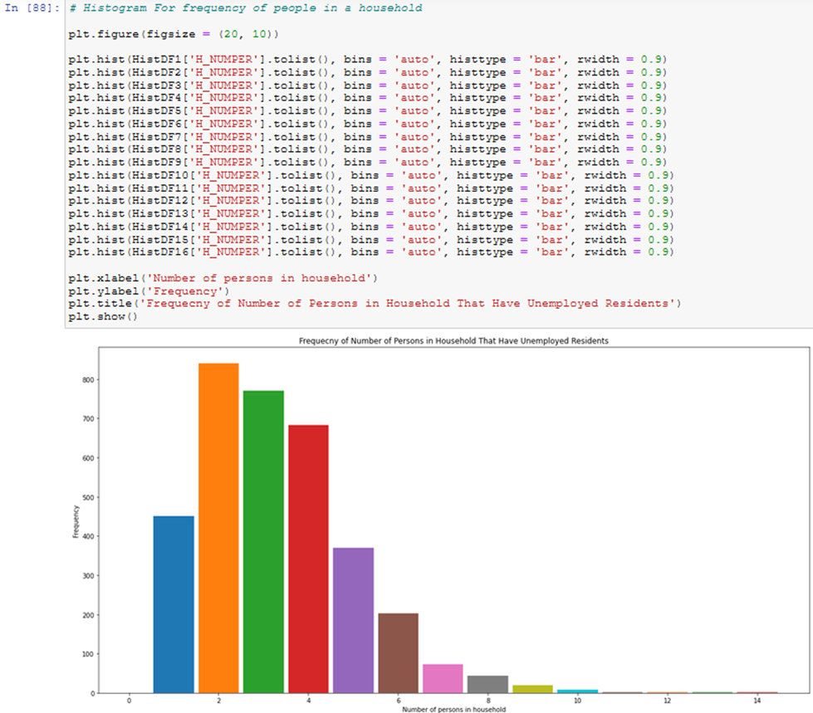

Description: Histograms use quantitative (numerical data) variables to show the shape of how the data was distributed. This means it can display how the data was skewed left or right; representing that the data is positive or negative. it can also display the data as normal or is symmetrical bar shaped plot. The X-axis represents the bin ranges while the y axis gives information about frequency.

**Scatter plot -**

Description: Scatter plots are used to displays 2 dimensional and, or 3 dimensional of variables related to each other. The purpose of this plot is to find the correlation which defines the relationship between the variables plotted along the 2 axes. The individual points(dots) in the scatter plot represent the values plotted and can show patterns of the data.

**Stack Plot**

**Description**: is used to show a progress or a trend over time between one and more categories. It displays a stacked area plot where each part is staked or added into one another. Each part of the stack represents a complete figure that has an x and y axis labels that are represented in different color. The color is to help the viewer understand the parts to the whole over time and is used to represent various datasets without overlapping each other.

**Multiplot**

Description: multiplot is to plot are used to compare two curves or show some gradual change in plot. Subplots are one method to that allows for programmer to plot more than one graph in a single figure.